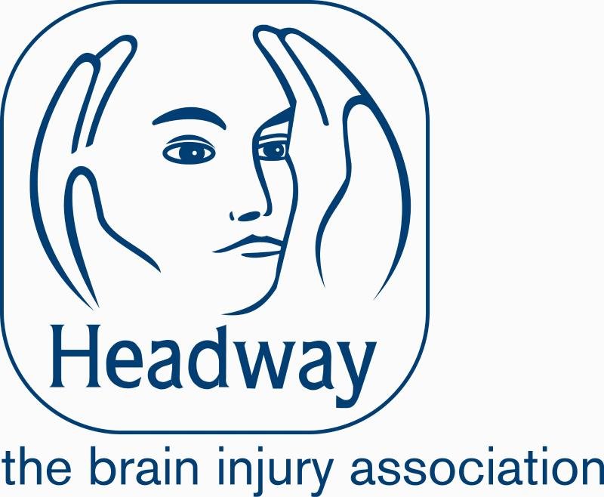
Headway Afternoon Tea at Wren Hall

Members of Headway Coventry and Warwickshire will be serving tea, coffee and homemade cakes at Wren Hall. All proceeds from the afternoon will go towards our Headway Support groups.
When: Sunday 24th September 2017 2.30-5.00pm
Where: Wren Hall, School Lane, Wroxhall CV35 7ND
Headway Coventry & Warwickshire run three support groups; one in Coventry, one in Nuneaton and one in Warwick. There is no booking or invite necessary to attend a meeting and they are free to join. The support groups are welcoming and friendly and are open to anyone connected with a brain injury – family members and carers as well as the person who has experienced an Acquired Brain Injury (ABI).

www.headwaycw.org.uk
Phone: 07745525698
E Mail: Headwaycw@aol.com
Facebook: Headway Coventry and Warwickshire

